**Final Project**

**CPE 301**

Spring 2024

Tyler Kwist

Overview

The purpose of this project is to compile everything we have learned over the semester into one piece of work. We have been asked to create a swamp cooler, which will make use of a fan motor, a temperature/humidity reader, a water sensor, a stepper motor, an lcd screen, and a series of buttons, LEDs, and different resistors. Each of these components uses various methods of collecting information, with differentiating software and hardware methodology, and requires an in–depth understanding of the programming and circuitry to work in tandem. We have also been asked to implement an RTC, but I was unable to implement it as asked in this project.

Results

Through approximately 3 days of researching, planning, and testing, the swamp cooler came out to be a success. The system will enter RUNNING mode as a fan turns on once a certain temperature is reached, and off once the temperature falls below the threshold; the temperature and humidity is monitored at all times besides DISABLED and ERROR modes; the stepper motor properly represents the ability to turn a fan; and the water sensor properly detects water levels and will push the program into ERROR mode if found to be too low. All LEDs function according to the state the program is in, the reset button will pull the system back into IDLE mode from ERROR once water is restocked, and the power button will send the system between IDLE and DISABLED modes. Below are pictures of the system in each mode, as labeled.

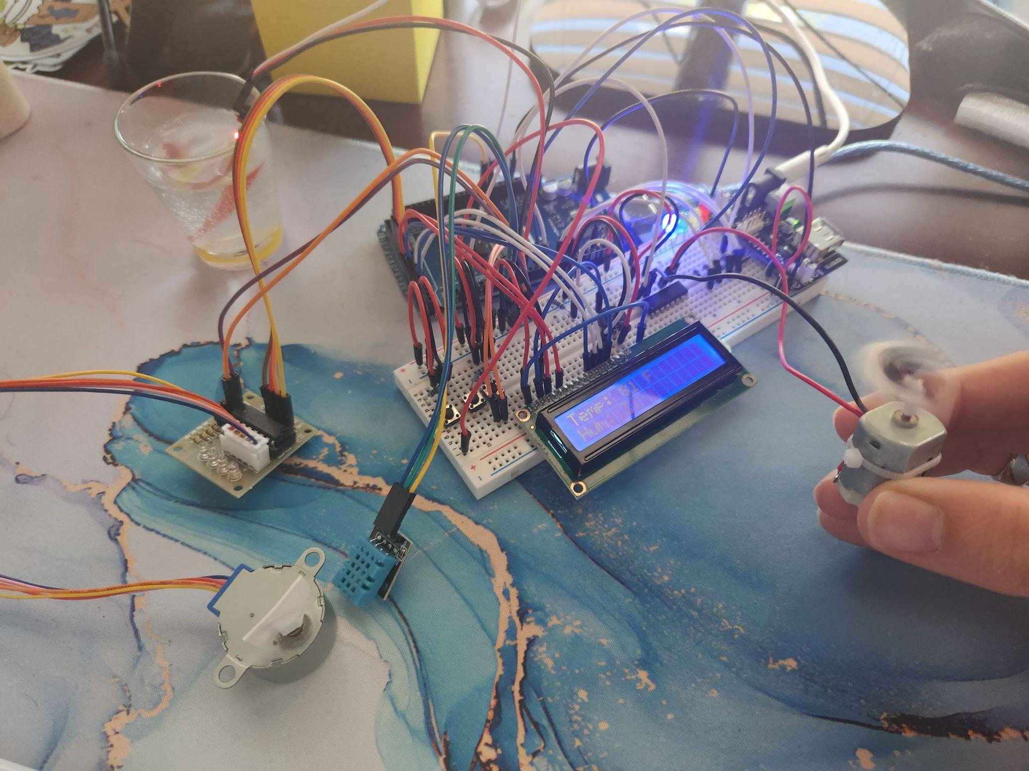Image 1: Running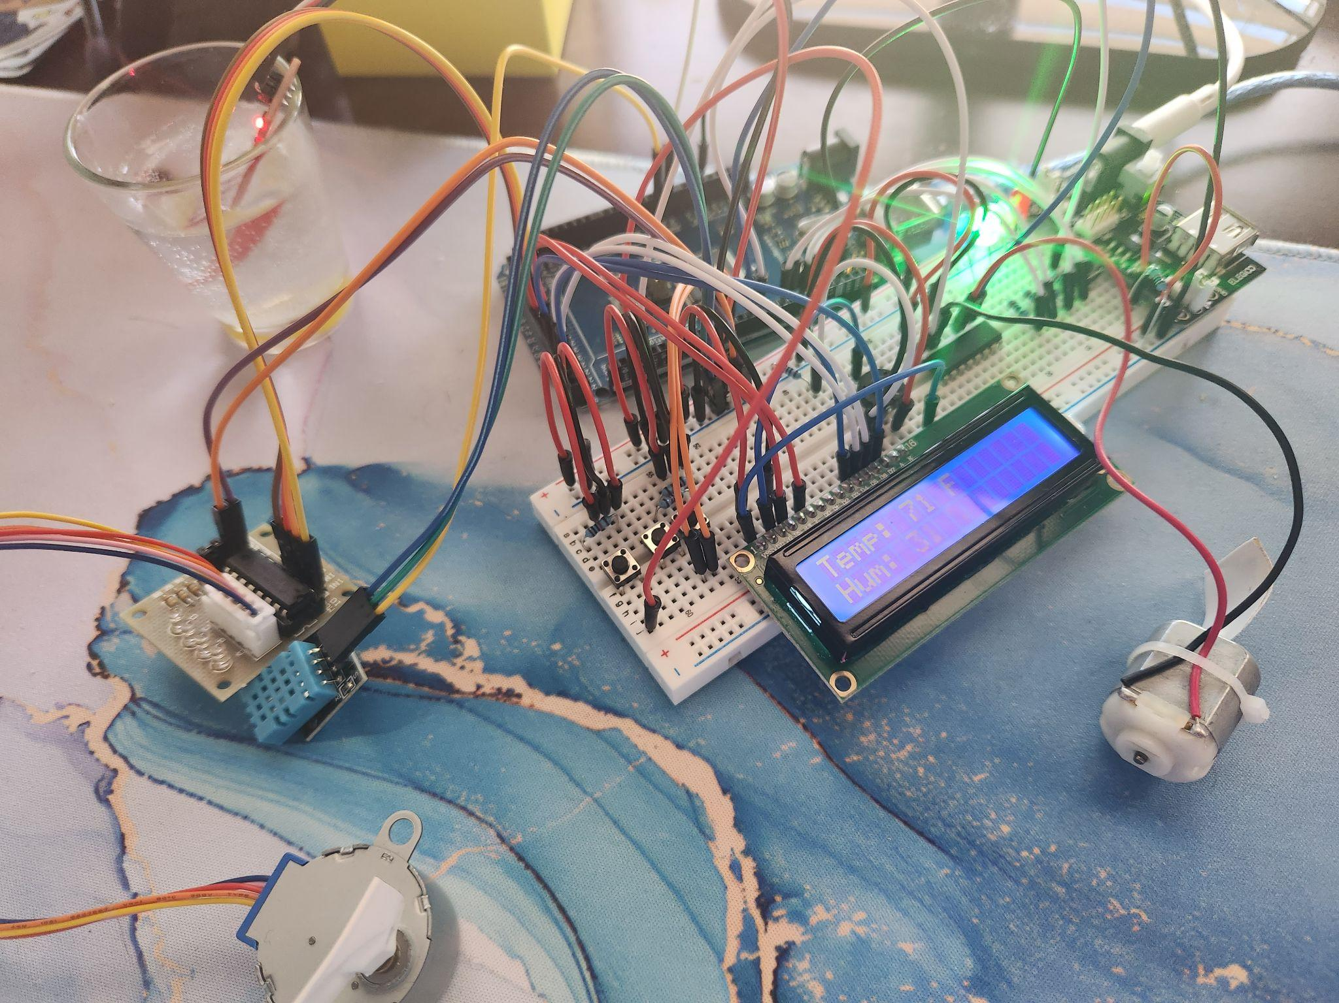Image 2: Idle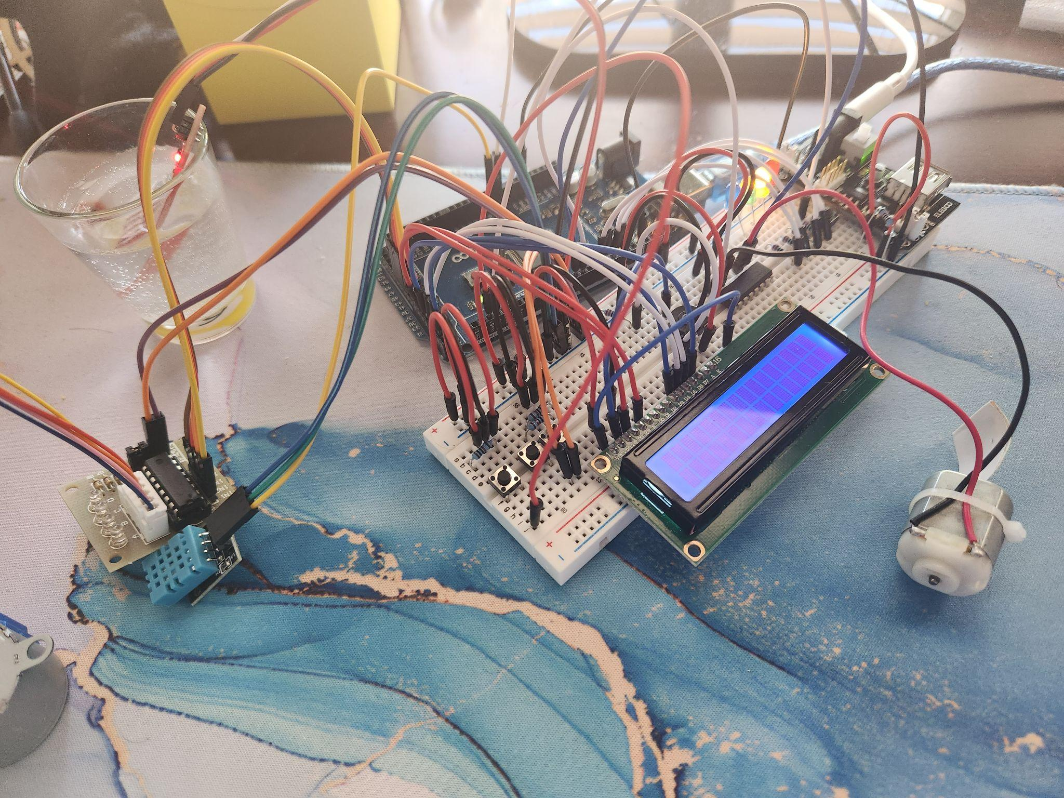Image 3: Disabled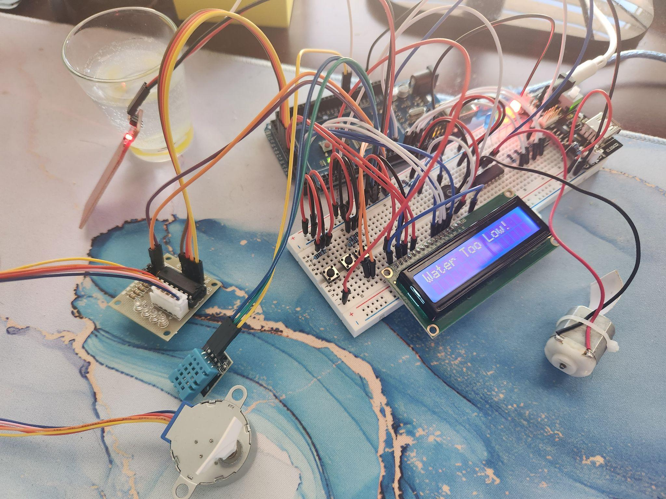Image 4: Error

Below is the final schematic of the entire system.

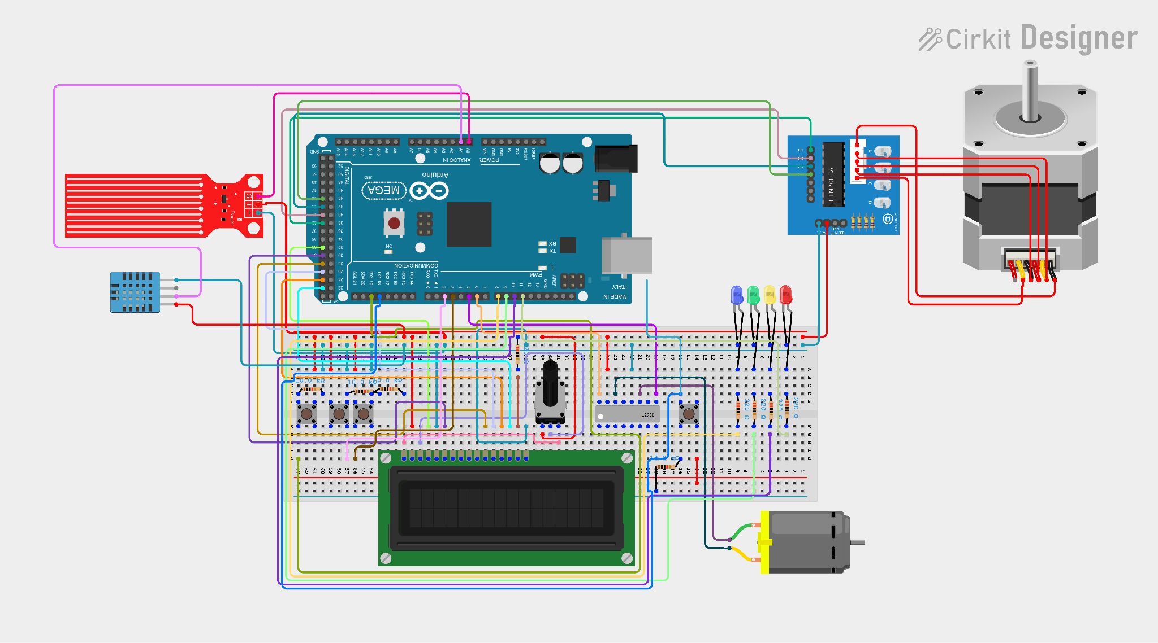

Link to video: <https://youtu.be/WkVMFbxdOXA>

Link to GitHub: <https://github.com/Kwist-Tyler/CPE_FINAL_PROJECT>